# Informatica PowerCenter Installation FILES DOWNLOAD – Version 11.1.1.7.0 for Microsoft Windows x64 (64-bit)https://edelivery.oracle.com/osdc/adf/images/t.gif

**KEY STEPS TO ACCESS ORACLE E DELIVERY CLOUD TO GET A COPY INFORMATICA POWERCENTER INSTALLATION**

* Oracle e delivery cloud is the key location from where we can get the latest informatica PowerCenter installation version.
* To access we must have account on Oracle Cloud.
* Login to Oracle e delivery cloud website using the URL <https://edelivery.oracle.com>
* Below snips indicate the page you will get once you are in the website.
* Type “Oracle Informatica” in the search box provided as shown below.
* We will get the result as “REL” release file as shown below
* Click on it and it will get added to cart
* Next step is to choose platform (Microsoft windows 64 bit in my case)
* Accept “Oracle standard terms and conditions” and click continue
* You will list of installation files
* There will be some previous version installations as well
* Choose the latest and click Download
* Wait for Download to finish, it will be taking a while since the file size runs in GB.

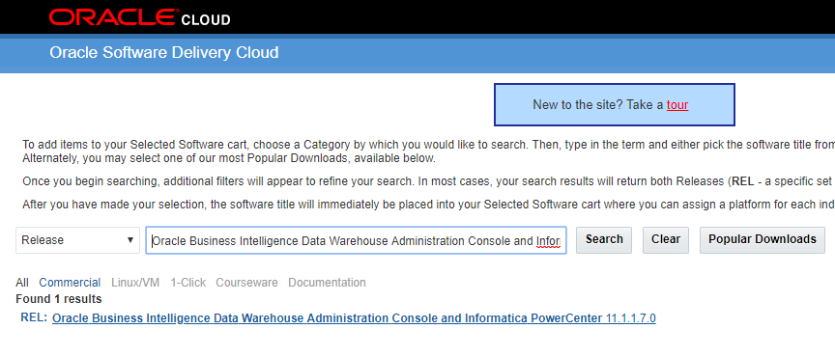

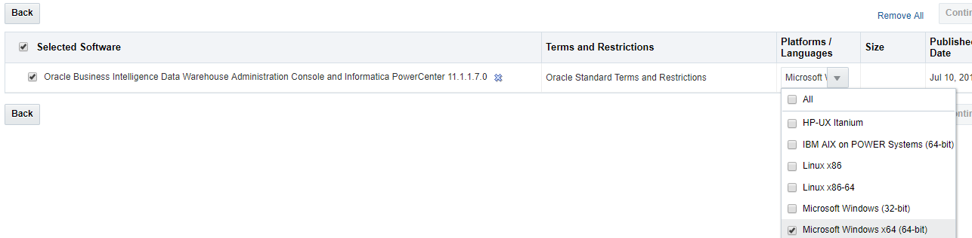

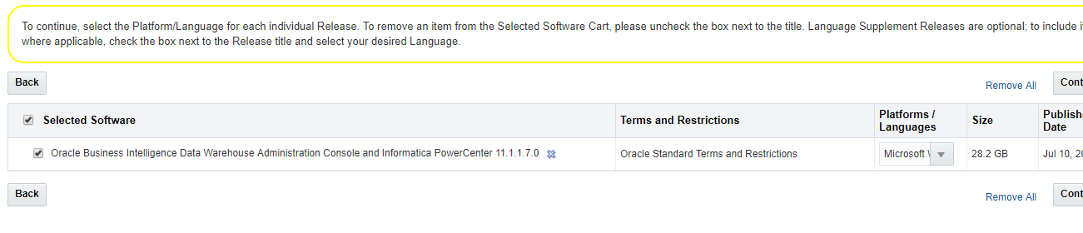

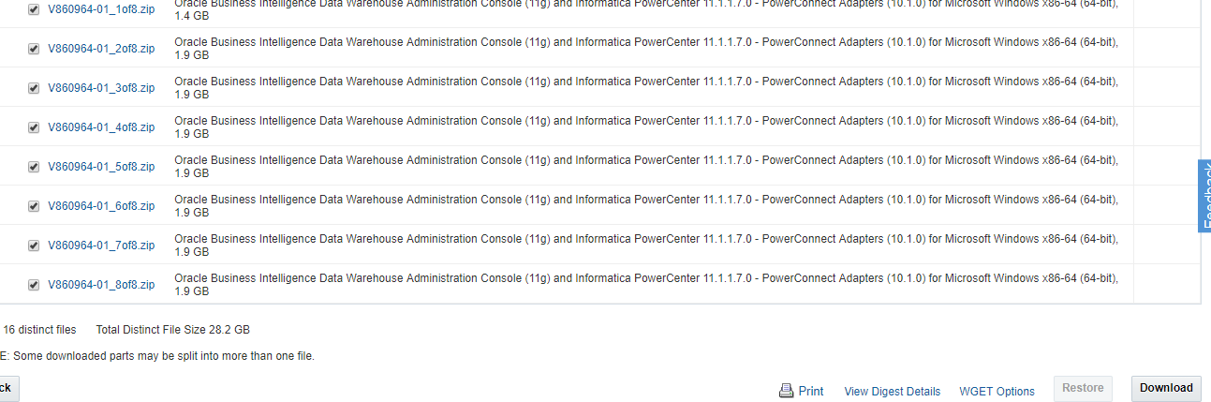

THANK YOU